# Set up aggregated Api to create work order

1. Login to Azure Portal; navigate to respective resource group -> API Management Service.
2. Click on ‘APIs -Preview’
3. Go to Publisher Portal.
4. Click on ‘Add API’.

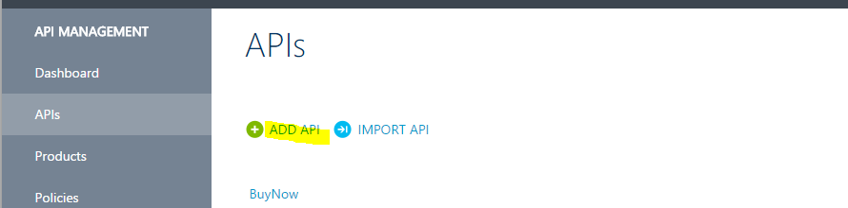

1. Enter below highlighted details and Click ‘Save’.

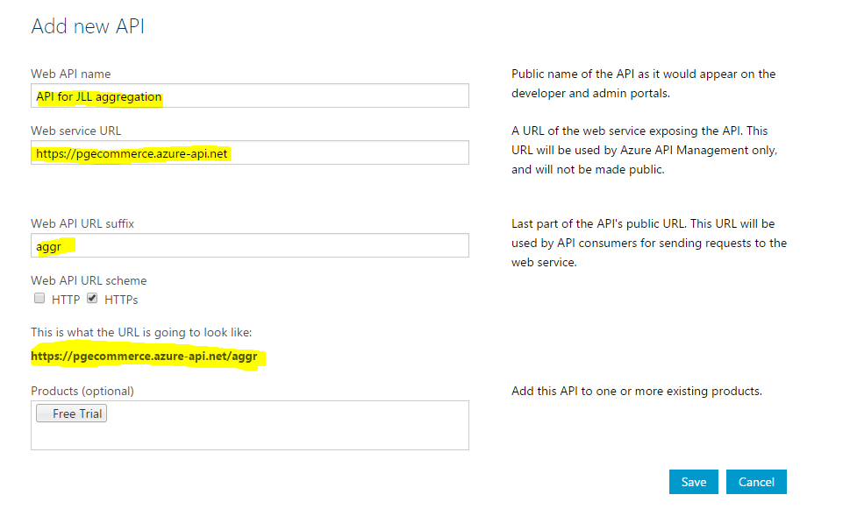

1. Click on ‘ADD’ Operation.

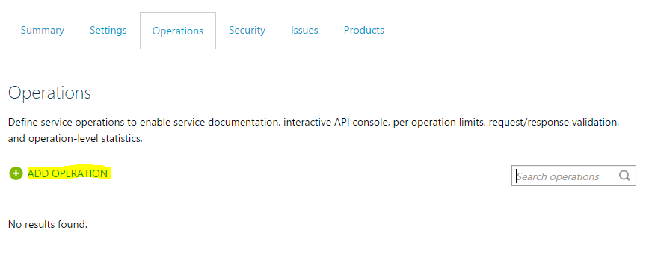

1. Enter highlighted details for both screenshots and click ‘Save’.

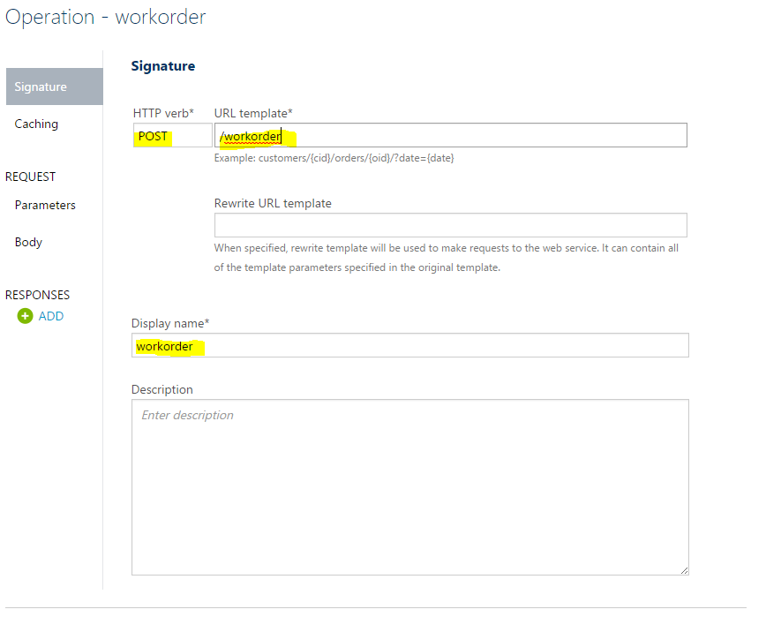

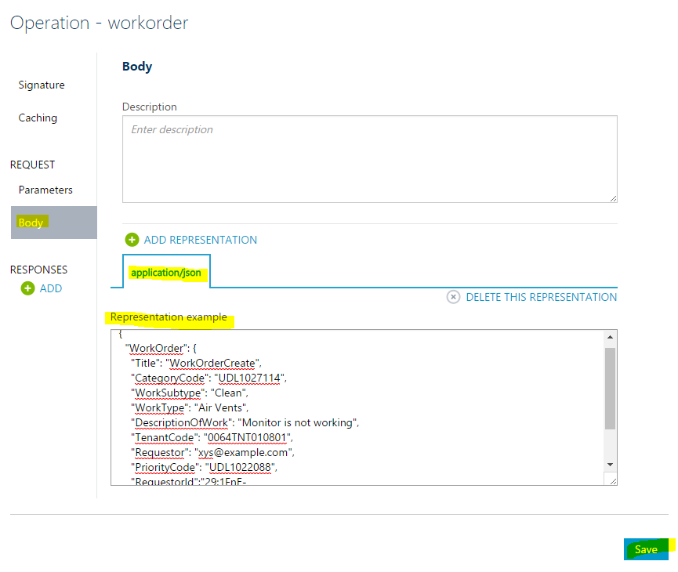

The above body JSON as:

***{***

***"WorkOrder": {***

***"Title": "WorkOrderCreate",***

***"CategoryCode": "UDL1027114",***

***"WorkSubtype": "Clean",***

***"WorkType": "Air Vents",***

***"DescriptionOfWork": "Monitor is not working",***

***"TenantCode": "0064TNT010801",***

***"Requestor": "xys@example.com",***

***"PriorityCode": "UDL1022088",***

***"RequestorId":"29:1FnE-gdUEBY5j8vY7LKYtgrWLLvOzuLHAN5VbegVP7trngAmaxfqWHX7g46x1f-2F"***

***}***

***}***

1. Go to Policy Editor; Policies -> PG API Version -> click on ADD Policy.

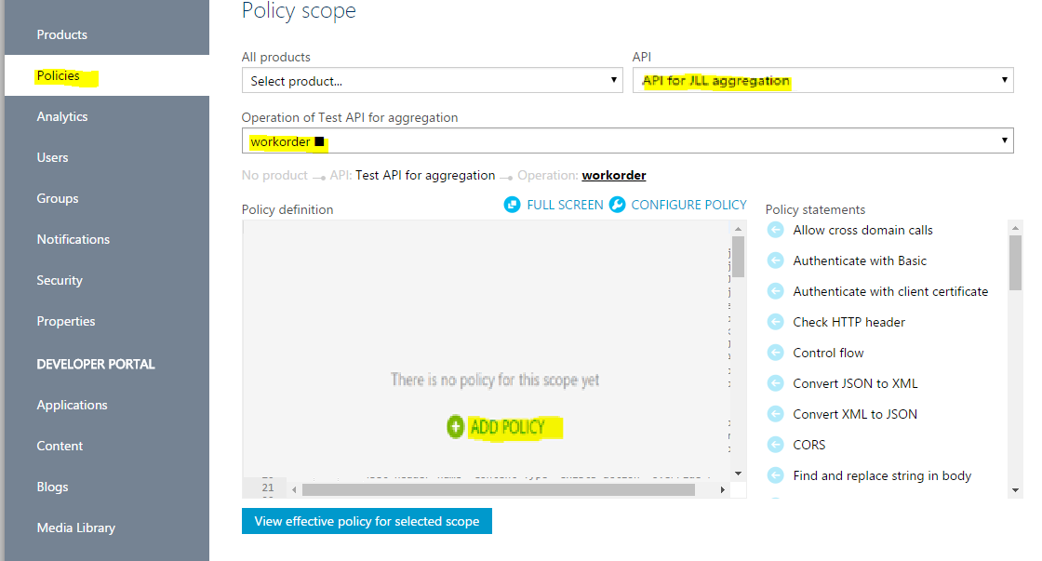

1. In the Policy editor, copy content from below attached text file and save the policy.



Note:

* 1. In the above text file, before saving the policy, change the access token under policy <set-header> for JLL API.
  2. The JLL API for POST call to create work order:

<https://qa.jllapi.com/ifmintegration/maintain/v1/workorder/>

Below is the Request Body for JLL API:



1. The output JSON response of the aggregated API is as below:

***{ "data": { "workSubtypeCode": "UDL1027554", "order": { "userId": "29:1FnE-gdUEBY5j8vY7LKYtgrWLLvOzuLHAN5VbegVP7trngAmaxfqWHX7g46x1f-2F", "workOrderId": "MQA21260444-1" } }, "status": { "statusCode": "", "message": "Order Placed Successfully", "code": "200" } }***